פיתרון לתרגיל 10

Online data entry and a program of one-way ANOVA can be found at http://www.physics.csbsju.edu/stats/anova.html

Two-way ANOVA (how to use Microsoft Excel): http://helios.bto.ed.ac.uk/bto/statistics/tress8.html

שאלה מס' 1
In a hypothetical experiment, aspirin, Tylenol, and a placebo were tested to see how much pain relief each provides. Pain relief was rated on a five-point scale. Four subjects were tested in each group and their data are shown below:
Aspirin Tylenol Placebo
3 2 2
5 2 1
3 4 3
5 4 2

Analysis see at http://www.ruf.rice.edu/~lane/stat_sim/one_way/index.html

שאלה מס' 2



פתרון :

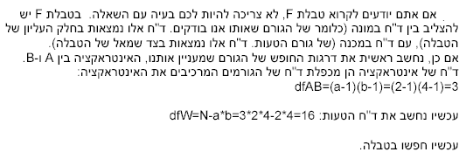

שאלה מס' 3

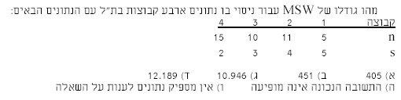

פתרון :

